[ZANG] - [Chuanjie] - ITCAssignment

Student ID: 699382953

[chuanjiezang@gmail.com](mailto:chuanjiezang@gmail.com)

Part 1: Modifying the Account and AccountTest Classes

Modify the Account class

Add a withdraw method to the Account class that checks to see if the amount withdrawn is less than the account balance. If the withdrawal amount is greater than the account balance, print a message indicating the problem.

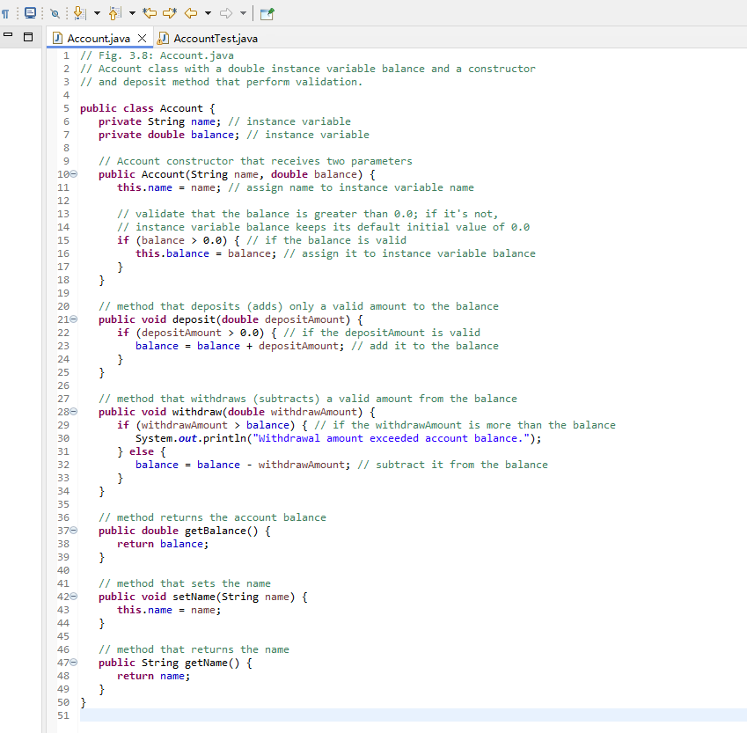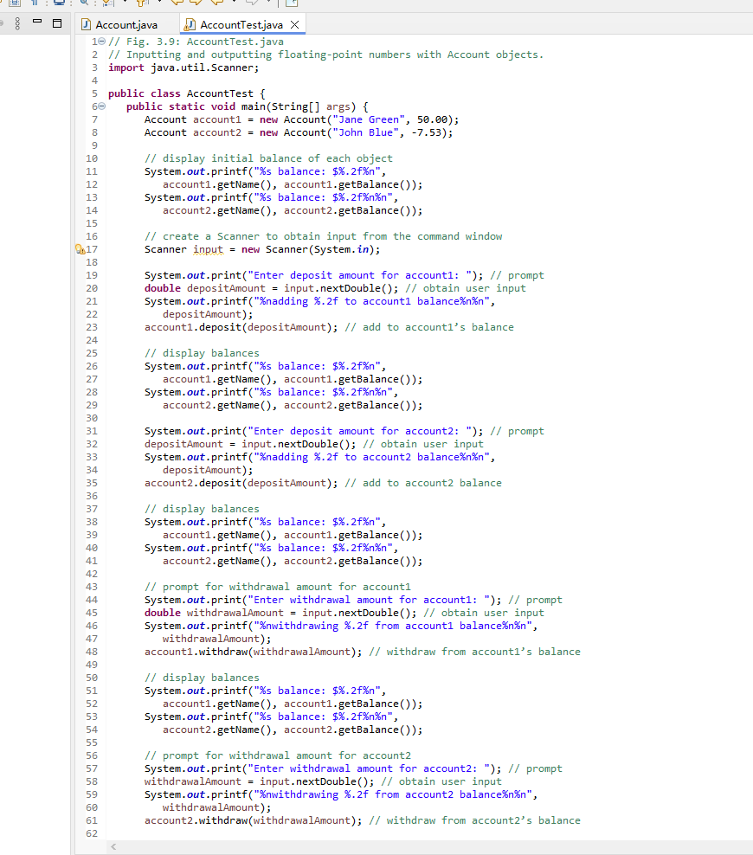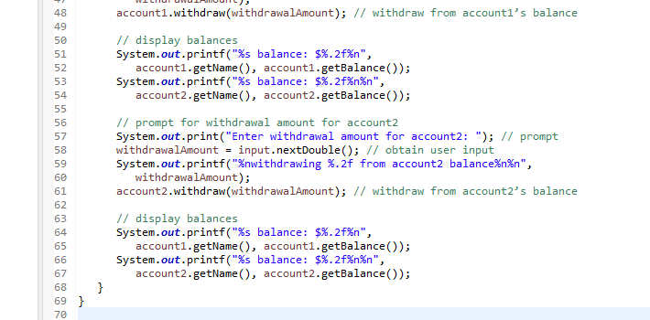

Part 2: Implementing the Employee Class and its Test Classes

